CCT College Dublin

Assessment Cover Page

Module Title: | Machine Learning for Business
Assessment Title: | CA1
Lecturer Name: | Dr. Muhammad Iqbal
Student Full Name: | Karina Francieli Schmidt
Student Number: | 2023314
Assessment Due Date: | 24/04/2024
Date of Submission: | 24/04/2024 23:59 pm

Declaration

By submitting this assessment, I confirm that I have read the CCT policy on Academic Misconduct and understand the implications of submitting work that is not my own or does not appropriately reference material taken from a third party or other source. I declare it to be my own work and that all material from third parties has been appropriately referenced. I further confirm that this work has not previously been submitted for assessment by myself or someone else in CCT College Dublin or any other higher education institution.

CLUSTERING AND TIME SERIES

by

Karina Francieli Schmidt
2023314

Higher Diploma in Science in Data Analytics for
Machine Learning
Dr.Muhammad Iiqbal
CCT College
Dublin, Ireland

INTRODUCTION

Machine learning focuses on the development of algorithms and techniques that allow computer systems to learn from past data and experiences, without the need to be explicitly programmed for each specific task. Clustering is a machine learning technique that focuses on unlabelled data sets, grouping similar objects into distinct clusters or groups. k-means is one of the simplest and most widely used clustering algorithms. It groups data into k clusters, where k is a user-defined parameter.
Regardless of the algorithm chosen, clustering plays a crucial role in exploratory data analysis, identifying patterns and generating valuable insights from unlabelled data sets. It allows data to be segmented into meaningful groups, making it easier to understand and interpret the data, and is a powerful tool for making informed decisions in a wide range of domains and applications.
Time series are observations made over time, such as temperature values, product sales or share prices. Analysing time series involves identifying patterns, trends and seasonality in the data in order to make future predictions. Models such as SARIMA (Seasonal Autoregressive Integrated Moving Average) are used to model and forecast time series, taking into account autoregressive, moving average and seasonal components. The model forecast is used for planning and decision-making in a wide variety of areas, including finance, economics, meteorology and the social sciences.
SARIMA (Seasonal Autoregressive Integrated Moving Average) models are an extension of ARIMA models that incorporate seasonal components. They are widely used to forecast time series that exhibit seasonal patterns, such as household electricity consumption over time. SARIMA includes additional parameters to capture seasonality, allowing the model to better fit the recurring patterns in the data. By fitting a SARIMA model to historical data, it is possible to make future forecasts, known as model forecasts. These forecasts are generated by the SARIMA model and extended beyond the observed data, providing valuable insights for planning and decision-making. However, it is important to assess the accuracy of the forecasts and consider the uncertainty inherent in time series models when interpreting the model results.

CLUSTERS
DATA UNDERSTAND

For this project, the dataset chosen is called ‘education’, and its information is related to the US government on education, from 1970 to 2019, the percentage of adults who have or have not completed high school, college or associate's degree and bachelor's degree in different states.
Using the ‘.shape’ and ‘.info’ functions, you can see that the size of the data consists of 3283 rows and 50 columns, which are made up of numerical and categorical data.

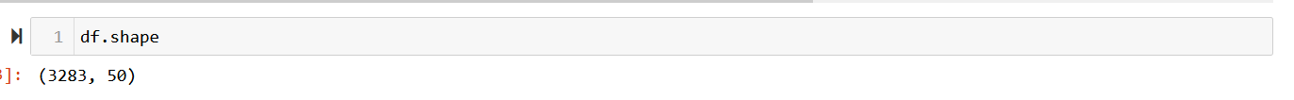
Figure 1 – Shape

After using ‘.info()’ I realised that there were missing numbers, which I replaced with zero. I also renamed the two columns I chose to work with by short names, as the column names were long. Next, I used Scatter plot (figure 2) to create a scatter graph where the points are coloured according to the conditions that were defined in the codes for ‘x’ and ‘y’. If the value of the ‘HSD 1970’ column is greater than 3 and if the value of the ‘HSD 2015-19’ column is greater than 4. If both conditions are met for a given line, the colour 'red' is assigned to that line. Otherwise, the colour 'blue' is assigned.

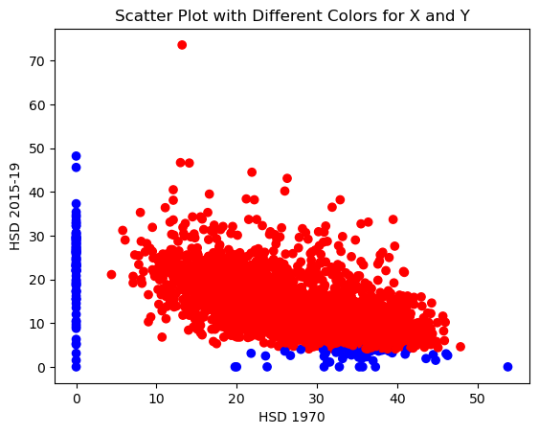
Figure 2 – Scatter Plot X e Y

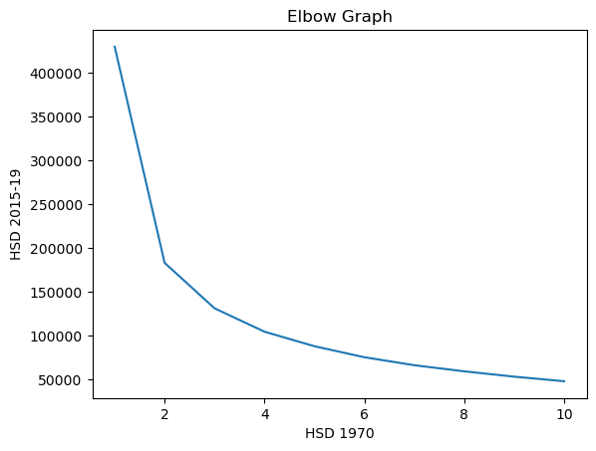
Figure 3 – Elbow Graph

In this case, the elbow graph (figure 3) was used to find the optimum number of clusters in a data set for clustering algorithms. It represents the relationship between the number of clusters and the variation within each cluster. The point where it starts to decrease dramatically from number 4, this indicates the optimum number of clusters. From this point onwards, adding more clustering does not significantly reduce WCSS. So, using the elbow graph we can visualise the optimum number of clusters for the chosen dataframe.
The two clustering methods chosen were Kmeans and Kmedoids. I chose Kmeans because it is usually efficient for most data frames, has well-defined clusters and is easy to interpret. Kmedoid is very similar to Kmeans, but uses the actual data points to represent the clusters.
After using the elbow graph, Kmeans (figure 4) created 4 distinct clusters and we can see the centroids in red. Visualising the graph, we can see that one of the clusters has many outliers. Before starting the clustering, the box plot shows that the High School Diploma (HSD 2015-19) has the highest number of outliers.
When Kmedoid is applied (figure 5), we can see a very similar division of the clusters, with one of them having a lot of outliers.
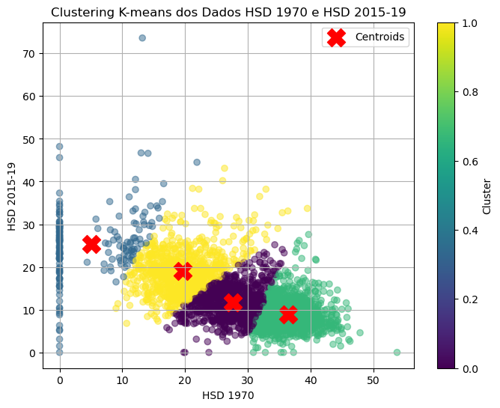
Figure 4 - Kmeans

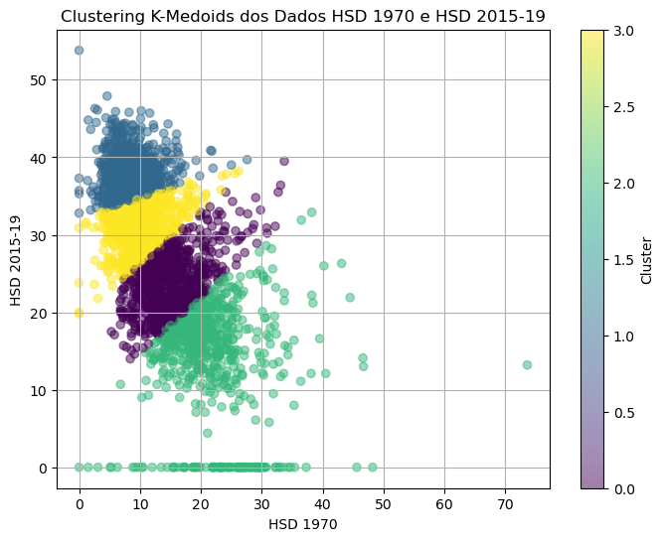
Figure 6 - Kmedoids

There have been many problems with Silhouette (Figure 6), I've tried several different codes, I've run them countless times, every time it says that ‘x’ is not defined. I tried converting the data type of the column, but the error persisted. But after a lot of trying, it finally worked. The Silhouette Score, when closer to 1, indicates that the points are closer to their clusters and farther away from the others; when the number is negative, it could be that the cluster has been assigned to the wrong cluster. In the dataset analysed, the number was 7, a high number, which indicates that the clusters are not very close to their centroids.
For Davies-Bouldin, the lower the value, the better, as this indicates that we have well-separated clusters. The closer it is to zero, the more well separated the clusters are. In the daset used, we also obtained 7, which shows that we didn't have such well-separated data.

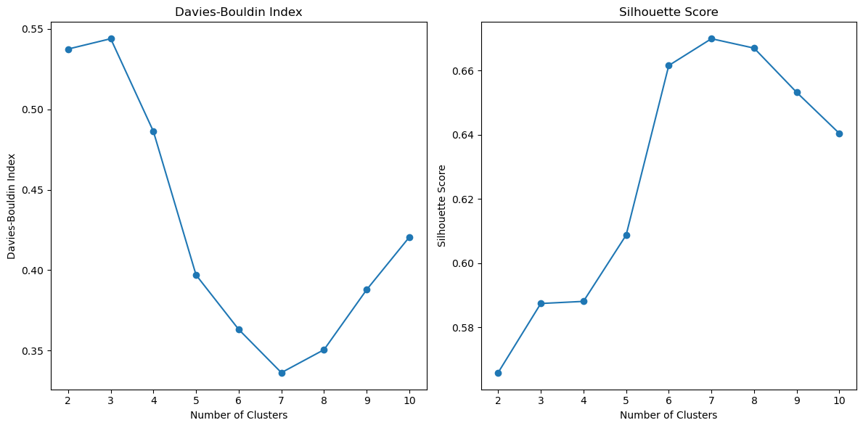
Figure 6 – Comparison Davies and Silhouette

TIME SERIES
DATA UNDERSTAND

For this project, the dataset that was chosen is named ‘DBEREL02.20240421124714’, and whose information is related to the Irish government's Household Electricity Consumption.
Using the ‘.shape’ and ‘.info’ functions, it is possible to see that the data size consists of 240 rows and 10 columns, which are made up of numerical and categorical data.
In the model forecast, the coefficient of determination (r2) must be between 0 and 1, where 1 means that the model worked perfectly, and 0 indicates that the model is not the best. In this dataser we obtained a value of -9.412483e+07.
The graph (figure 7) provides a visualisation of household electricity consumption forecasts for the next 3 years, along with confidence intervals for these forecasts. It is useful for planning and making decisions related to electricity supply and future demand.

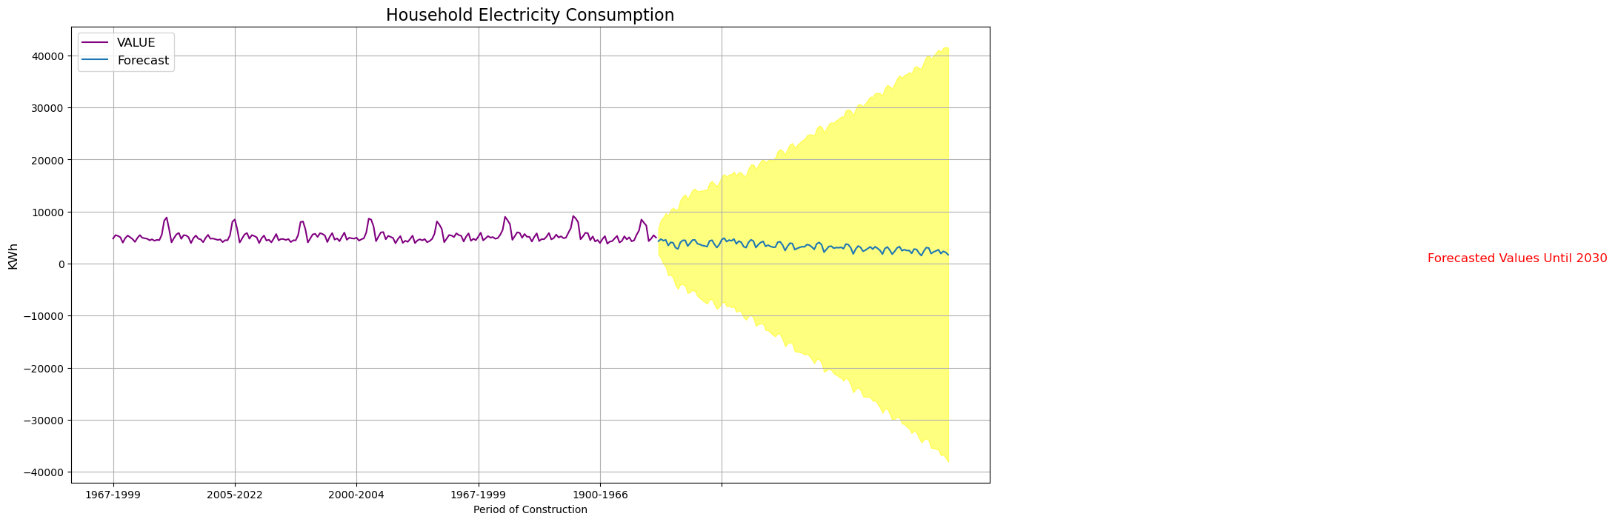
Figure 7 - Future forecast

CONCLUSION
In the first dataset on education, which was worked on with Kmeans and Kmedoids clustering. using 4 clusters after making the comparison using Silhouette and Davies, we had a high number for both which shows us that the clusters may not be s
In the electricity dataset, the model didn't work so well, with the r2 value not reaching 1.
o well separated.

REFERENCES

Altamimi, A.B. (2023). Big Data in Education: Students at Risk as a Case Study. Engineering, Technology and Applied science research/Engineering, Technology and Applied Science Research, 13(5), pp.11705–11714. doi:https://doi.org/10.48084/etasr.6190.
‌Guimarães, R.A., de França E Silva, A.L.G., de Souza, M.R., Guimarães, A.M., de Souza Lauro, M.E., Naghettini, A.V., Neves, H.C.C., Arantes Manso, F.P., Júnior, C.V.B., de Castro, A.R.M., Bento, V.G. and da Cruz Lima, P.L.M. (2023). Trend and spatial clustering of medical education in Brazil: an ecological study of time series from 2010 to 2021. BMC health services research, [online] 23(1), p.882. doi:https://doi.org/10.1186/s12913-023-09795-9.
Hong, S. (2024). An Exploration of the Practical Path of Internet Civic Education in Student Management in Colleges and Universities Based on K-means Clustering. Applied Mathematics and Nonlinear Sciences, [online] 9(1). doi:https://doi.org/10.2478/amns.2023.2.01162.

Scrucca, L., Saqr, M., López-Pernas, S. and Murphy, K. (2023). An introduction and tutorial to model-based clustering in education via Gaussian mixture modelling. [online] arXiv.org. doi:https://doi.org/10.48550/arXiv.2306.06219.

Shen, Y. and Lei, C. (2024). Research on evaluation of university education informatization level based on clustering technique. Heliyon, [online] 10(4), p.e25215. Available at: https://doaj.org/article/215f6dda64bb44a1b3ec007125f6e225 [Accessed 24 Apr. 2024].

Guimarães, R.A., de França E Silva, A.L.G., de Souza, M.R., Guimarães, A.M., de Souza Lauro, M.E., Naghettini, A.V., Neves, H.C.C., Arantes Manso, F.P., Júnior, C.V.B., de Castro, A.R.M., Bento, V.G. and da Cruz Lima, P.L.M. (2023). Trend and spatial clustering of medical education in Brazil: an ecological study of time series from 2010 to 2021. BMC health services research, [online] 23(1), p.882. doi:https://doi.org/10.1186/s12913-023-09795-9.
‌

‌

‌

‌

